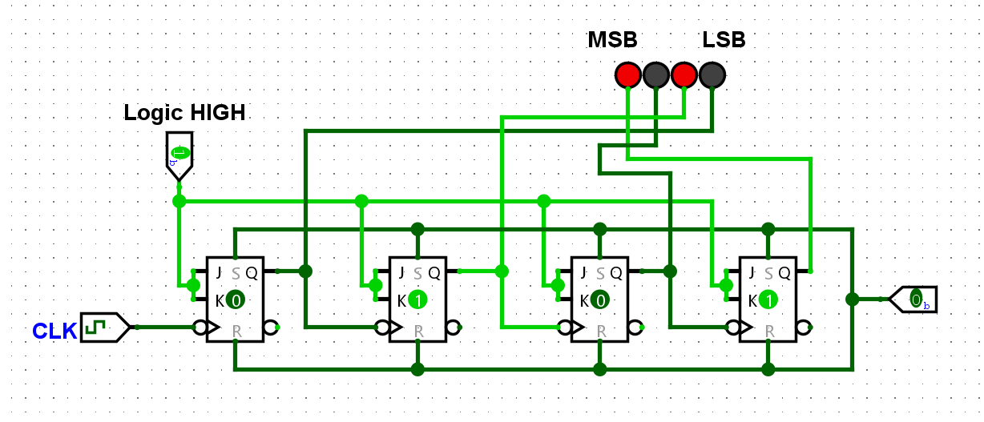
Figure 1: JK Flip Flop Implementations of a 4-bit Asynchronous Up-Counter
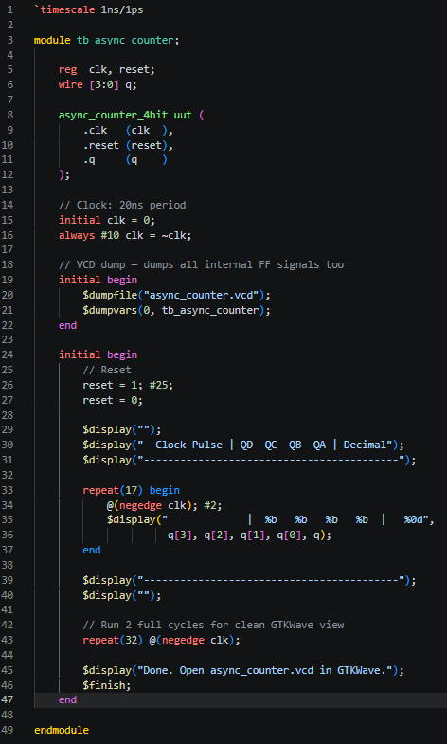
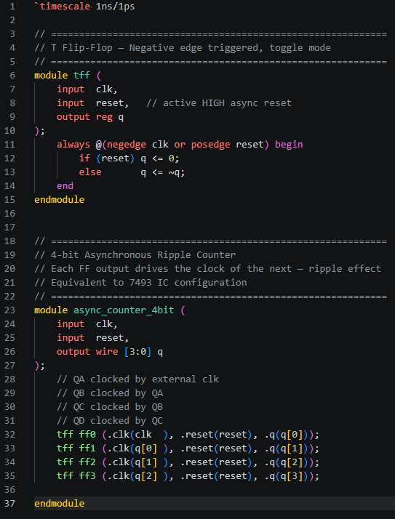

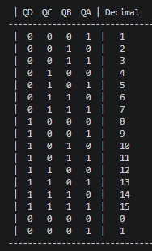

Figure 2: Verilog script and Truth table for the T-type Flip Flop Implementations of a 4-bit Asynchronous Up-Counter
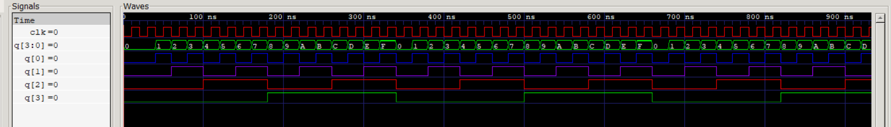
Figure 3: Signal Response for the T-type Flip Flop Implementations of a 4-bit Asynchronous Up-Counter

